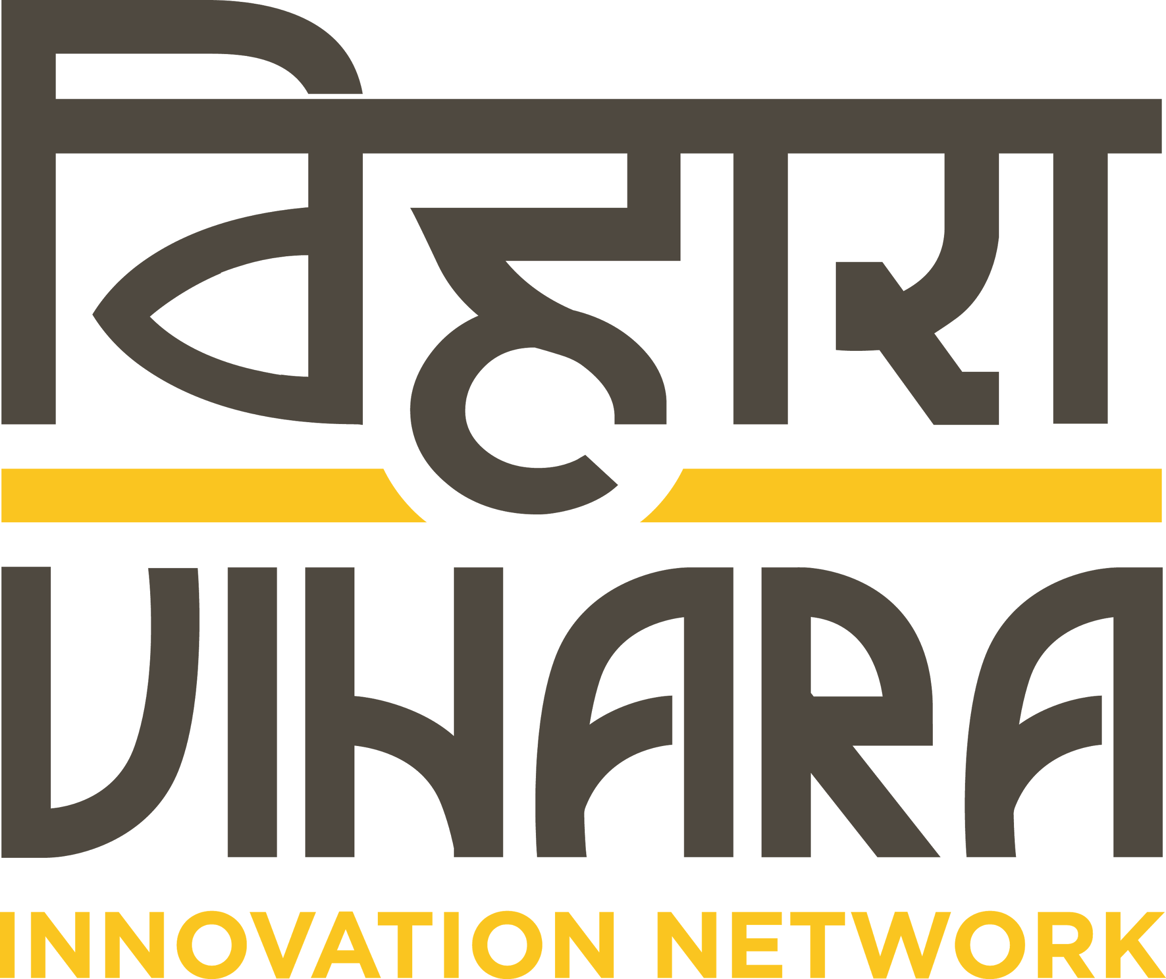

Vihara is a user centered driven social impact enterprise. Our work involves working on some of the most pressing challenges in Public Health such as Immunization, Quality of care, Maternal & Child health. Vihara works along the complete cycle of innovation - from using ethnographic research to gather behavioural insights, designing innovative solutions to address complex systemic challenges, to working with relevant partners to create implementation pathways for ideas to become real and aid uptake of innovations.

Vihara’s has a strong theory of impact oriented towards improving quality of care in public health, especially in the fields of maternal health, Child health & Immunization. We are an extremely agile organization, with roles and functions that cut across disciplines, and are looking for people who are comfortable handling multiple responsibilities, have a managerial bent of mind, and most importantly who are as dedicated as us in achieving meaningful social impact.

Designation: Service Designer
Location: Delhi
Experience: 4-7 years
Date of Joining: Immediately

Educational Qualifications:
Bachelors or Masters in Design (Information Design, Communication Design, Graphic Design, Visual Communication, Design Strategy, Design Management, or Service Design)

Required Skills & Experience

- Experience in designing systems and services with components of process, digital media,
and products in the health, public service and/or development sector. Your portfolio should
highlight piloted or implemented service solutions. Experience in designing for and
implementing health services for low resource settings is most valuable.
- Strategic understanding of the user centered design process, with experience in
developing and leading teams through tailored design methods for public innovation
projects. Experience with designing new design tools and methodologies, as well as
employing established tools for co-design, concept generation and rapid prototyping for
product and service solutions.
- Experience in designing and conducting ethnographic research and design research in
rural contexts
- Ability to synthesize data from multiple-perspectives, interpret it in new, relevant and
actionable ways, and identify patterns to drive creative direction and opportunity and
solution development
- Ability to communicate insights through powerful and clear information design i.e.
reports, data visualizations, illustrations, storyboards, photographs, videos and other
multimedia techniques.
- Innovative problem solving skills demonstrated in day to day management, and the
ability to handle crisis situations appropriately
- Creative leadership skills in order to manage a multi-disciplinary team, and steer output.
- Superior written and verbal communication, in order to clearly articulate analysis, design
directions and decisions for quality documentation and reports
- Strong planning and time management skills to lead design teams in delivering projects
on time &amp; on budget
- Commitment to using creative expertise for development and social change.

Key Job Responsibilities

- Synthesize field data to build strategic frameworks, and provide design direction at a programmatic level, as well as on a day to day basis

- Ensure the project is delivered on time, and facilitate coordination between various
members of the team.
- Identify key design opportunities based on field insights and provide a rich evidentiary
basis and stimulus for program decisions such as overall innovation direction, theory of
change, key evaluation indicators.
- Work beyond just design, in also selling our innovations and services by working in
tandem with the Business development team to modify designs as per client needs,
create concise concept notes, and be a design expert in client meetings
- Lead the solution generation process from field driven co-design activities, concept
creation, and field prototyping to user feedback etc.
- Design and facilitate collaborative workshops, brainstorming, code sign activities within
the team, as well as with clients and project partners
- Work closely with relevant team members on creatively packaging design work and
learning’s into narrative documents, reports, presentations, process notes and blogs
- Build and finesse in-team capacity around the design process and ensure clear
expectation setting for roles and deliverables
- Liaise with partner organizations i.e. design advisors, monitoring, learning and evaluation
teams, implementation partners and clients through the project
Advantages
- Prior experience of working in Public Health
- Experience and comfort in working in low resource and rural environments
- Keen visual design sense
- Proficiency of working with Adobe Creative Suite

Interested candidates can send in their application along with your writing samples/ portfolios to vihara@vihara.asia with the subject line “Service Designer”.

