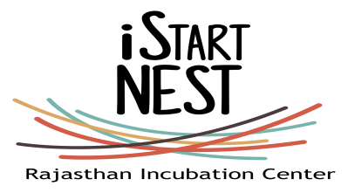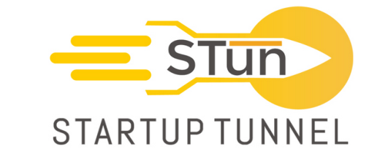

Acceleration Lead

Startup Tunnel is an early stage incubator and an accelerator located in Delhi. Startup Tunnel in partnership with Government of Rajasthan will run the iStart Nest Incubators program in Jaipur, Rajasthan. During the program we will focus on providing mentorship to passionate teams to enhance their capabilities in product development, marketing strategy, and design & user experience. We will be working with start-ups in various development sectors such as Travel Tech, Scalable Solar & IoT, Agri Tech, Civic Technologies, Digital Health and Regional Language Technologies.

The position is based out of Jaipur. The candidate will work in close coordination with the Delhi team and will be reporting to Project Director

Job Responsibilities

- Design effective campaigns for high-quality deal flow generation and scouting activities including organisational and financial due diligence.
- Lead the developing and designing of the actual acceleration program.
- Incharge of conceptualizing the acceleration program framework and delivery schedule of the bootcamp and acceleration program.
- Provide and ensure ongoing advisory support on key aspects of the business like strategic planning, financial planning, marketing, raising funding/investment and impact measurement for the iStart Nest Program.
- Working with the team to build global and local partnerships with engineering colleges, state governments, CSR’s, angel network, venture funds and other ecosystem players, enablers and builders.
- Continuous identification and onboarding of high-quality mentor network to support the acceleratees
- Organising and conducting regular community Events, Meet-ups, Workshops, Mentor hours, Investor Connects, Hackathons for the benefit of the founding teams and ecosystem at large.
- Lead bi-monthly progress report drafting and seeking timely approvals from Delhi head office. Support the team in the overall smooth functioning of the acceleration facility.
- Own and maintain relationships with mentors, investors, venture funds, angel networks, coworking spaces, the government of Rajasthan and other ecosystem players
- Ensure constant generation of regional content including acceleratee stories, case studies that can be shared on various social media sites
- Managing a team of 2-3 people and reporting the progress of the acceleration program, progress made by accelerates and other additional stuff on a daily basis.
- Ensuring onboarding of new founding teams onto the iStart Nest platform on weekly basis.
- Along with the team managing, supporting and providing end-to-end services to a total number of 10 founding teams.

Skillset / Profile

- Excellent organizational, interpersonal and communication skills
- Knowledge of business, financial planning & financial modelling
- Comfortable networking, attending events, conferences and making connections
- Ability to independently lead and execute projects
- Ability to thrive in a fast paced, dynamic start-up environment
- Willingness to travel as needed
- Ability to understand business and product challenges quickly
- Willing to mentor and help and guide teams directly
- An existing network of relevant contacts in India or abroad
- Strong social media and social networking skills

Education / Experience

- 5 years of relevant startup or venturing experience
- Prior experience building a startup is preferred
- Prior experience with incubators, accelerators or funds is preferred
- Engineering, Finance, Business degrees or other relevant education

Interested candidates can send in their applications their CV and cover letter specifying the fitment for the role to the HR Manager at vihara@vihara.asia ASAP

