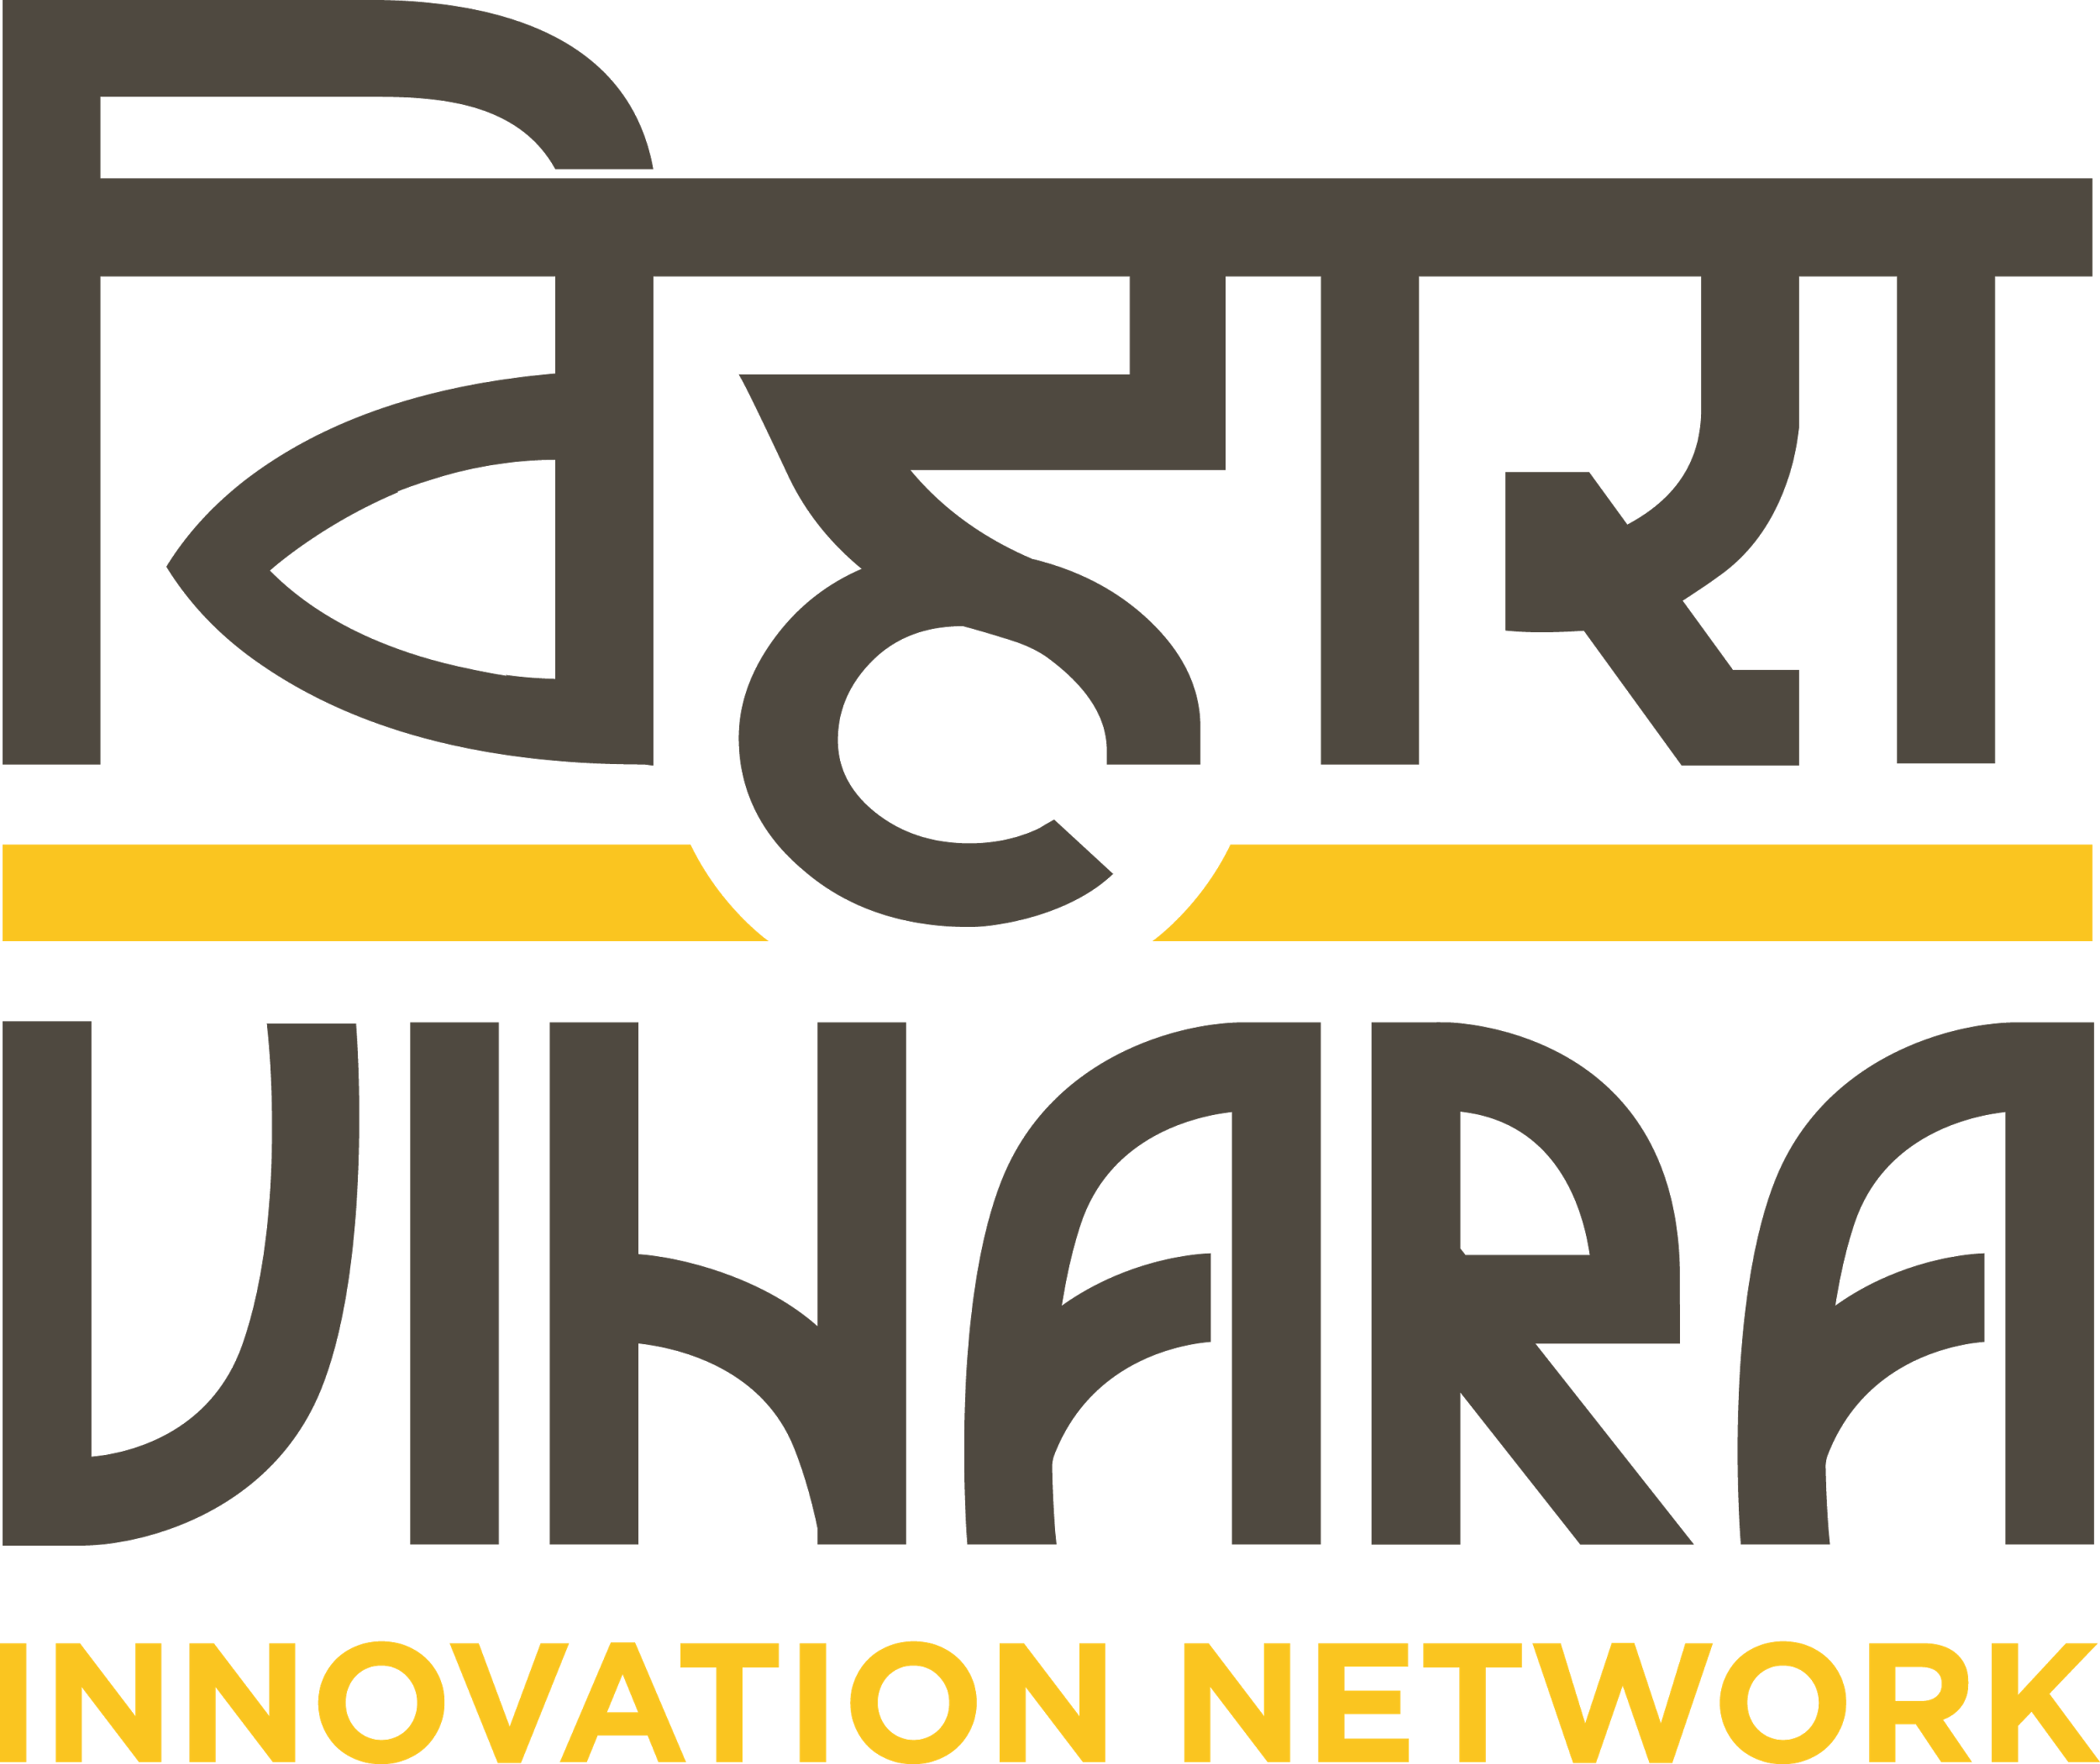

Vihara is a user centered driven social impact enterprise. Our work involves working on some of the most pressing challenges in Public Health such as Immunization, Quality of care, Maternal & Child health. Vihara works along the complete cycle of innovation - from using ethnographic research to gather behavioural insights, designing innovative solutions to address complex systemic challenges, to working with relevant partners to create implementation pathways for ideas to become real and aid uptake of innovations.

Vihara’s has a strong theory of impact oriented towards improving quality of care in public health, especially in the fields of maternal health, Child health & Immunization. We are an extremely agile organization, with roles and functions that cut across disciplines, and are looking for people who are comfortable handling multiple responsibilities, have a managerial bent of mind, and most importantly who are as dedicated as us in achieving meaningful social impact.

Designation: Design Researcher
Location: Delhi
Experience: 4-7 years
Date of Joining: Immediately

Educational Qualifications:
Bachelors or Masters in Design (Information Design, Communication Design, Graphic Design, Visual Communication, Design Strategy, Design Management, or Service Design)

Here’s what the job looks like:

- Participate in the planning and design of qualitative research studies including screening, recruiting, and developing field instruments
- Conduct fieldwork in a variety of locations utilizing an array of ethnographic techniques and best practices
- Participate in rigorous analysis and synthesis process, identifying patterns, key insights, and opportunities
- Translate and prioritize opportunities into business implications.
- Frame research findings to present a compelling, actionable story
- Create field, interim and project reports
- Contribute actively to the company’s blog and share knowledge created during the course of project through social media platforms
- Represent the organisation nationally and internationally through conferences, convening, meetings, as well as other outreach activities including knowledge dissemination and business development

You own this if you have:

- Experience writing content and creating supporting visuals for project deliverables (decks, concept sketches, design criteria, user criteria)
- Data visualization capabilities (create diagrams, illustrations and frameworks)
- Proven ability to plan, create supporting materials and facilitate workshops, ideation and co-creation sessions
- Tendency to adopt collaborative approaches to problem solving and ideation
- Ability to differentiate and lead convergent and divergent brainstorming activities
- Ability to generate quick, diverse and several concepts during ideation and brainstorming sessions
- Good planning and time management skills for effective task management
- Keen to learn and open to new ways of working
- Excellent verbal and written communication skills

Extra Credit:
- Social media savvy
- Cloud evangelist
- Design software maestro

Interested candidates can send in their application along with your writing samples/ portfolios to vihara@vihara.asia with the subject line “Design Researcher Position”.

