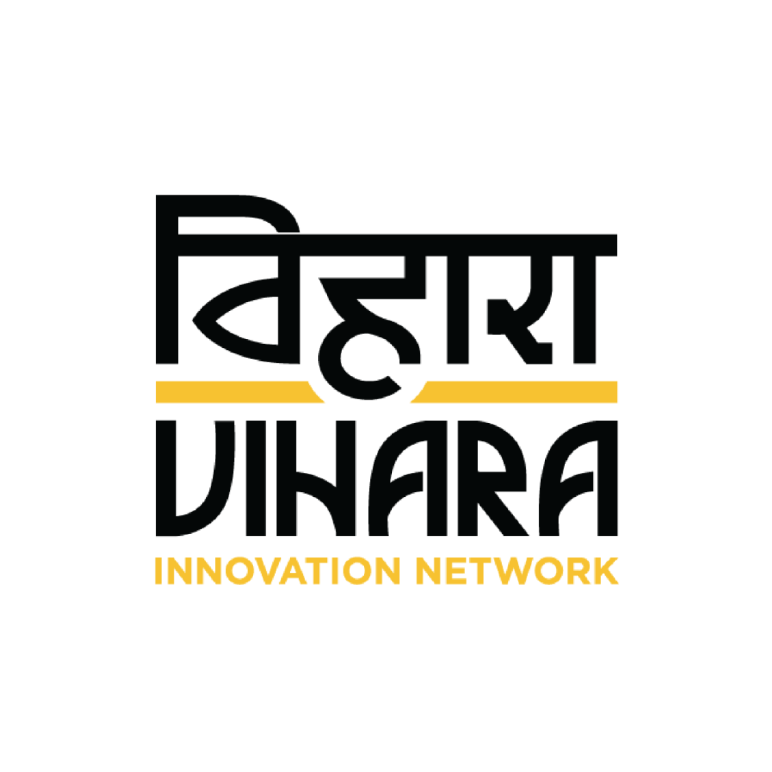

Job Title: Senior Design Researcher

The context

Stanford University is partnering with Vihara Innovation Network on WASH UP! Evaluation Project which is a collaboration between Stanford University, World Vision, and Sesame Workshop.

It features a combined education and infrastructure sustainability program with two objectives: (1) to improve the knowledge and practice of safe WASH behaviors among primary school students and (2) to improve the sustainability of WASH service delivery at schools. The education portion of the program consists of a curriculum developed by Sesame Workshop. The purpose of the infrastructure sustainability intervention is two-fold: (1) to ensure that existing WASH infrastructure on school premises are always functional and (2) to ensure that the necessary WASH consumables, such as soap and water for handwashing, are always available.

Stanford University is seeking to collaboratively design an infrastructure sustainability intervention with Vihara, that incorporates insights from the systematic review conducted by Stanford around existing WASH service deliveries as well as insights from an in-depth formative research to be conducted by Vihara at the ground level. The infrastructure sustainability intervention will be implemented in 100 rural government primary schools across the Sitapur district, Uttar Pradesh.

What will your day-to-day look like?
- Lead the team in planning, designing, implementation and management of research studies including screening, recruiting, developing field instruments, etc, and intervention solutions.
- Conduct in-person fieldwork across Sitapur district, U.P. utilizing an array of design research techniques and best practices.
- Lead rigorous data synthesis and analysis; identification of patterns, key insights, and opportunities and provide a rich evidentiary basis and stimulus for program decisions such as overall innovation direction, theory of change, key evaluation indicators, etc.
- Lead the packaging of design work and learnings into narrative documents, reports, presentations, process notes and blogs.
- Build and finesse in-team capacity around the design process and ensure clear expectation setting for roles and deliverables.
- Provide technical assistance to strengthen the capacity of project staff, partners and other staff to design and implement quality programming.
- Liaise with partner organisations i.e design advisors, monitoring, learning and evaluation teams, implementation partners and clients through the project.
- Strengthen collaboration with the key stakeholders and partners including funders for shared results through addressing both supply and demand side issues.
- Identify and write technical and programmatic briefs as appropriate and disseminate and promote sharing information and initiatives through relevant channels.

Role
We’re looking for a curious and enthusiastic Senior Design Researcher with relevant work experience (5-6 years) in the public health space, gained through working on a portfolio of HCD/DT/Research projects. A collaborating spirit and an understanding of behavioral insights and insights led design is necessary to be able to design effective human-centric solutions.

Design Research and Strategy
- You will lead the design process and research strategy for the team; drive the design analysis and solution development process; and will work closely with project partners.
- A large part of the project involves co-creation with external stakeholders. You will lead the design and facilitation of collaborative workshops, brainstorming sessions, codesign activities within the team, as well as with clients and project partners.
- The role also requires liasoning with potential clients, developing design concept notes, and refining already existing designs.

Team Management
- You will be leading a cross disciplinary team consisting of researchers, designers, public health experts and partnership team members.
- Planning program activities, tracking and reporting progress, man managing the various team members and keeping the entire team engaged and motivated are the primary responsibilities under this aspect of the role.

Good to haves ( skills / experiences )
- Bachelors or Masters Degree in Product Design / Service Design / Interaction Design / Digital Design / User Experience Design / Social Design / Strategic Design Management
- A combination of relevant technical experience in research and design as well as partnership, planning and management skills.
- Experience in designing systems and services with components of process and products in the health, public service and/or development sector. Your portfolio should highlight piloted service solutions. Experience in designing for health services, primarily in the WASH sector for low resource settings and/or prior experience of working with children or in schools is most valuable.
- Strategic understanding of the user centered design process, with experience in developing and leading teams through tailored design methods for public innovation projects.
- Knowledge of public health related issues, sensitivity to cultural differences and understanding of the political and ethical issues surrounding public health issues; superior written and verbal communication skills.
- Knowledge of relevant stakeholders within the community of practice, donors and their strategies.
- Proficiency of working with Adobe Creative Suite and ability to communicate insights through powerful and clear information design i.e. reports, data visualizations, illustrations, storyboards, photographs, videos and other multimedia techniques.
- Proficiency with Hindi, a plus if fluent in the regional language of Central U.P. (eg. Awadhi)

How to apply
To apply for this job, please write a succinct email describing your interest in this position, and attach a writing sample, your up to date CV and a portfolio if you have one. Please highlight experiences that are relevant to the description mentioned above.

Send it to vihara@vihara.asia

About Vihara
Vihara is one of India’s leading design led social innovation practices. It has been working in this sector for more than a decade, and has deep expertise in bringing innovation to social development.

Our teams are multi-disciplinary, representing wide expertise areas such as Design, Research, Management and more. Our way of working involves tying together these various technical skills to achieve the common goal of making social systems work for people. As such, we like to think of our team as changemakers, rather than identify them by their technical specialities.

You can read more about our work on our website

